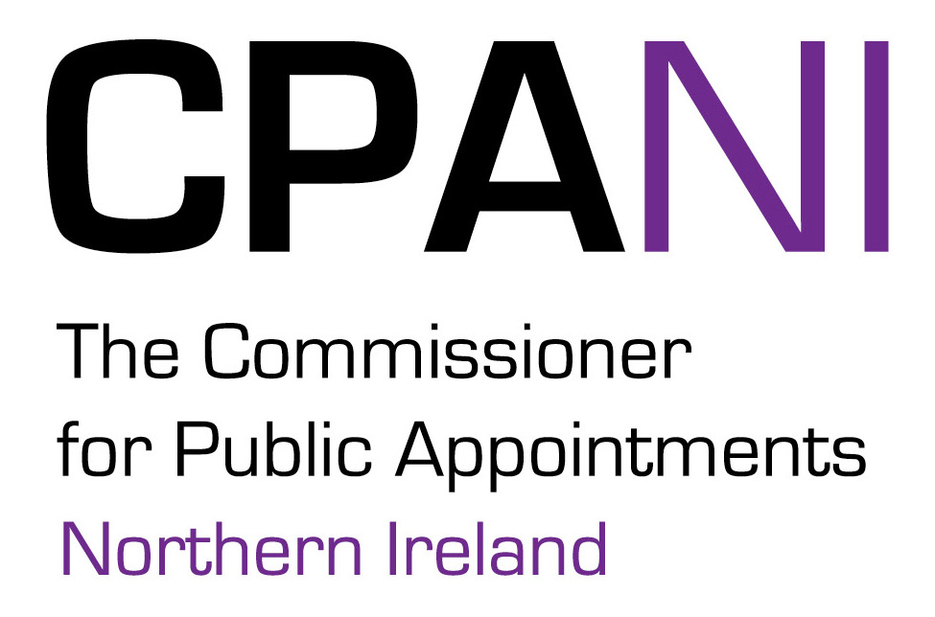

CPANI Internal Complaints Procedure
CPANI deals with complaints about public appointment processes, in which it investigates, on behalf of a complainant, complaints about how a Department of Government has treated him / her.
CPANI must also have a procedure for dealing with complaints about itself. This is that ‘internal’ procedure. It provides those dissatisfied with the services provided by CPANI the opportunity to make a complaint. It allows for complainants to have their complaint resolved and is designed to help if you are unhappy with the quality of service provided, for example in relation to:
- Maladministration (i.e. failing to follow the right procedures);
- Delays in receiving information/responses within stipulated timeframes;
- Difficulty in contacting the correct person;
- Incorrect information or guidance issued by CPANI;
- Attitude or conduct of CPANI staff; or
- CPANI performance that has fallen short of your expectations.

What we do when we receive a complaint
Complaints are handled confidentially, efficiently and with tact and understanding. Where an investigation must be instigated, we will ensure that no conflict of interest arises with respect to the investigating party or parties, e.g. the investigation will always be handled by someone other than the person about whom you are complaining.

Complaints Procedure
You can express your dissatisfaction in the following ways:
- Online: Using our Online Complaints Form available from the CPANI complaints webpage.
- By writing to: The Commissioner for Public Appointments for Northern Ireland, E5. 08, Castle Buildings, Stormont Estate, Belfast, BT4 3SR.
- By email to: info@publicappointmentsni.org marked ‘for the attention of the Commissioner’.
If not using the online form, please ensure that your email or letter is headed “Complaint - for the attention of the Commissioner”. Provide as much information as possible in your letter or email, along with contact details, such as your name, telephone number and postal address.

Step One
Submit your complaint by online form, email or letter. We will acknowledge receipt within 3 working days.
Within 10 working days we will either:
- Let you know that it is not possible to take action and explain why, or
- Send a statement of complaint to you that will:-
- Advise you who is handling your complaint;
- Set out the issues you have complained about to ensure that we agree these with you; and
- Explain what we can do in the event that the complaint is upheld.
We will provide a full response within 20 working days. If this deadline cannot be met, owing to the complexity of the complaint, you will receive an explanation that will inform you of when you can expect a full response.

Results of Investigation
We will write to you at the end of the investigation setting out our findings and any proposed action we intend to take. Where a complaint is upheld this will lead to an apology and to a review of our practices. This means that complaints can help to improve the way we conduct our activities.

Step Two
If you are not satisfied with the response you have received or the way the investigation was handled, you can ask to have your complaint investigation reviewed by the Commissioner, who will aim to reply within 20 working days. If this deadline cannot be met, you will receive an explanation that will inform you of when you can expect a full response.
The Commissioner will consider why you are dissatisfied and will review the work involved in the original investigation. The Commissioner will write to you confirming his conclusions and decision at the end of such a review. As with all complaints, if your concerns are upheld it will lead to an apology and to a review of our practices.
The Commissioner’s decision following an investigation is final. The Commissioner will not:
- Enter into protracted discussion with you about the outcome of the investigation;
- Re-open the investigation unless new evidence comes to light. Where you do provide relevant new evidence the Commissioner will consider this.
The Commissioner will:
- Clarify points raised in relation to his findings in any investigation;
- Respond to questions raised about the way the complaint has been handled.

